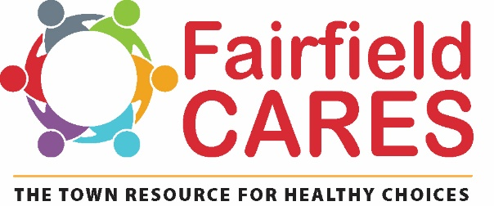

**501 Kings Hwy E. Suite 210, Fairfield, CT 06825**

**March 7, 2022**

**The Fairfield CARES Community Coalition’s Cannabis/Marijuana Advocacy Position**

Note: *In the document, Fairfield CARES has used the terms “cannabis” and “marijuana” interchangeably. Whichever term is used by the referenced study or agency, then that term is continued throughout that section of the document.*

**Introduction:**

Since 2009, the Fairfield CARES Community Coalition has been bringing community members together to prevent and reduce youth use of alcohol, tobacco, marijuana, and opioids. Pleased with the progress made to reduce youth alcohol use, the Fairfield Board of Selectmen, in 2013, designated the Fairfield CARES Community Coalition as the town’s Local Prevention Council.

Through the implementation of best practice strategies that has included educating parents, providing resources to Fairfield Public Schools, and working with our community partners to curb access and change social norms, Fairfield CARES has successfully reduced youth substance use significantly.

**Position:**

Fairfield CARES strongly believes that the town of Fairfield should adopt ordinance language that prohibits the retail sale, the advertisement, the cultivation, the processing and wholesale distribution of cannabis products. The town should strongly discourage home grown cannabis plants for both medicinal and non-medical purposes, where youth access is probable, in order to maintain a community environment that prioritizes positive youth development, and ensures that all our youth thrive.

**Rationale:**

According to the Substance Abuse & Mental Health Services Administration (SAMHSA), US Dept of HHS, in those states that have legalized retail marijuana for adult use, youth use of marijuana is higher than in states where marijuana is not legalized. Findings from the 2019 National Survey on Drug Use & Health found that 6.4% of 12-17 year olds in “non-legalized states” used marijuana in the past month, compared to 9.4% in “legalized states”. Further, youth in “legalized” states report that it is easy to get marijuana.(1)

**Impact of Marijuana Retail Location and Marketing and Youth Marijuana Use:**

A 2017 study found that a higher percentage of youth used marijuana if they lived in an area with higher density of marijuana retail establishments compared to those youth who lived in a lower density area(2). A 2018 study of 13-17 year olds found that youth’s marijuana use was positively correlated with their perception of living near a marijuana retail store. The study also found the impact of location on youth marijuana use was moderated by youth’s attitudes toward the drug. The location of a marijuana retail establishment was more impactful on youth marijuana use if teens had existing favorable attitude toward marijuana(3).

While marijuana stores and the density of marijuana stores could be considered one form of advertising marijuana products, it is more likely that children will be exposed to marijuana marketing through social media, internet, and other mediums. A study for the CDC (Hongying Dai, PhD, November 2017) found that exposure to marijuana advertisements (via social media, internet, billboards, radio, magazines, etc) increased the likelihood of adolescents using marijuana. Dr Dai found that when youth were exposed to one source of marijuana advertising, youth had a 60% increase in the odds of being a current marijuana user. Those odds more than doubled when youth were exposed to three or more sources of marijuana advertisements (4). Megan Moreno, MD, MPH, and colleagues found that one in three teens in states with legal non-medical marijuana had favorite marijuana brands that they followed on social media. Their results showed that those teens who followed a favorite marijuana brand on social media were eight times more likely to have used marijuana in the last 28 days. “When 45% of youth report being online almost constantly, exposure to marijuana marketing on social media may put their health and futures at risk”(5).

**Addiction and Cannabis Use Disorder:**

Cannabis is addictive. The development stage of the adolescent brain is especially vulnerable to substance use given that it is primed for addiction. This does not mean that all children who use cannabis will become addicted. However, like tobacco, there is no safe or safer type of cannabis:

“people who use cannabis need to know that there is no universally safe level of cannabis use; thus, the only reliable way to avoid any risk for harm from using cannabis is to abstain from its use”(6).

In a 2019 report, the National Institute for Drug Abuse (NIDA), stated “people who begin using marijuana before the age 18 are 4 to 7 times more likely to develop a marijuana use disorder than adults”(7). This concurs with the results of a 2014 study (Volkow, Baler, Compton & Weiss) that showed when marijuana use begins in adolescence, those individuals are more likely to develop a marijuana use disorder within two years of first use compared to those who delay use until they are adults(8). Cerda` and colleagues compared adolescent non-medical marijuana use in legalized states and non-legalized states between 2008 and 2016 and found a 25% increase in adolescent marijuana use disorder among youth from states with legalized marijuana(9).

**Impact of Cannabis on the Adolescent Brain:**

Given that the brain is not fully developed until the mid-twenties, children’s brains are particularly vulnerable to the effects of cannabis. Youth cannabis use can reduce academic performance, impair cognitive processes important for driving or for participating in sports, and decrease motivation to maintain social engagement.

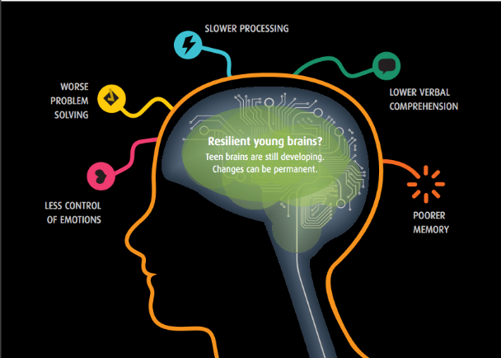 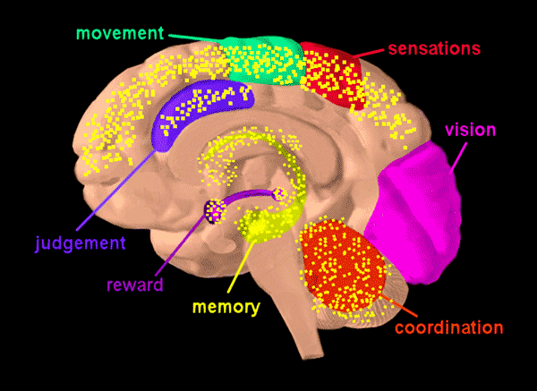

Short-term and/or long-term brain damage can occur to young brains if youth use cannabis daily and if the potency of THC is more than 10%. According to SAM’s “Lessons Learned From State Marijuana Legalization, 2020-2021 edition, “frequency of marijuana use, as well as, higher THC potency, is associated with the most severe impact on mental health, which is evidenced by psychosis, suicidality, reshaping brain matter, and addiction”(10) .

SAMHSA states in their “Evidence Based Resource Guide Series: Preventing Marijuana Use Among Youth”, that THC can impair a child’s brain by disrupting the normal circuits that control:

* Learning, memory, and other cognitive functions essential to learning
* Pleasure/reward systems
* Appetite
* Motion/motor control
* Sleep
* Reproduction/fertility
* Other possible effects include altered senses, changes in mood, and hallucinations(11)

**Potency:**

The potency of today’s cannabis is nothing like the cannabis of decades ago; the THC potency is significantly higher today. The average THC content in a cannabis flower can vary from 14% to 30%. The THC level in the “concentrates” can be 40% to 90% or higher. The higher the THC potency, the higher the risk of cognitive impairment, developing a cannabis use disorder, and psychosis. Any cannabis product that contains 10% THC or more is a product that impacts brain functioning.

**Perception of Risk:**

The presence of commercial marijuana establishments in Fairfield would reinforce the message that marijuana is not harmful. The existence of medical marijuana dispensaries already confuse youth. In general, youth’s perception of risk toward marijuana is inversely proportional to youth use. If adolescents do not believe that marijuana is harmful then they are more likely to use marijuana. Below is local Fairfield youth data depicting the past-30 day use and perception of risk data from 2014 to 2021. In all cases, the perception of risk should be significantly higher, and past 30-day use rates lower.

***% of youth who use marijuana in the past 30 days and % of youth who view marijuana use as harmful from 2014 through 2021***

|  |  |  |  |  |  |  |
| --- | --- | --- | --- | --- | --- | --- |
| **Fairfield Youth Data** | **8th Grade** | | **10th Grade** | | **12th Grade** | |
|  | Past 30-Day Use | Perception of Risk | Past 30- Day use | Perception of Risk | Past 30-Day Use | Perception of Risk |
| **2014** | 2% | 75% | 26% | 48% | 31% | 45% |
| **2016** | 3% | 80% | 21% | 45% | 31% | 32% |
| **2019** | 3% | 83% | 16% | 53% | 30% | 33% |
| **2021\*** | 2% | 75% | 5% | 57% | 14% | 48% |

*Data collected during Covid-19 pandemic, spring 2021

**FOR THE TOWN’S CONSIDERATION**

**Recommended Community Level Policies:**

According to SAMHSA, community risk factors for youth marijuana use include:

* Widespread availability of marijuana
* Greater marijuana outlet density
* More days and hours of marijuana sales
* Exposure to marijuana marketing
* Youth liking or following marijuana businesses on social media
* Owning marijuana-branded merchandise or having a favorite marijuana brand
* New marijuana products that attract youth

SAMHSA recommends the following community strategies to prevent youth use:

1. Regulation of the price of marijuana: a) increasing taxes based on weight/amount, THC content, or product price, and b) banning price promotions such as coupons, two for one deals, bulk purchases, sample give aways, and happy hours.
2. Regulation of marijuana retail outlets: a) limiting the number and location of retailers through licensing or zoning, b) limit hours/days of sale, c) banning those under the age of 21 in marijuana businesses, d) regulating where marijuana and related products can be sold, including using adult-only stores for marijuana sales and prohibiting the use of delivery services
3. Regulation of marijuana product manufacturing and packaging: a) banning marijuana products with added synthetic flavors and odors, b) banning THC-infused edibles likely to attract children and youth, such as candies, cookies, and beverages, c) banning THC infused alcohol and tobacco products, d) requiring child-proof packaging, transparency on product labels, including THC and CBD content and ingredients, e) require prominent graphic marijuana warning labels with varied and rotating messaging
4. Limitations on marijuana advertising and marketing: a) banning marijuana advertising on television, radio, billboards, and social media, b) if not banned, limiting advertising with youth audiences, c) removing marketing, promotion, and advertising dollars from admissible business expenses for state income tax calculations, d) funding public health media campaigns, and e) prohibiting health and therapeutic claims

**Other Concerns:**

Potential tax revenue from cannabis sales will not cover the costs of the negative impact associated with commercial cannabis in the community, such as increased youth access, increased addiction among youth and adults, increased likelihood of unsafe driving conditions to name a few.

Cannabis is a cash business because its use and sale remain illegal at the federal level; therefore, there is increased opportunity for crime. As a cash-based business there could be a lack of accurate accounting for tax revenue purposes.

**Public Location for Cannabis Use:**

The new CT Cannabis law states “For municipalities with more than 50,000 people, if they regulate the public use of cannabis, the regulations must designate a location in the municipality where public consumption is allowed.”(12) Fairfield CARES urges the town to clearly communicate and inform its residents and visitors that use of any cannabis product is prohibited on all public property, owned or controlled by the municipality, with the exception of the designated location for marijuana use.  That location should not be in a residential neighborhood, nor frequented by or visible to those under the age of 21. Please keep in mind that any location should minimize exposure to secondhand cannabis/ marijuana smoke. In comparison to cigarettes, marijuana smokers are inhaling 50% more benzoprene and 75% more benzanthracene, both are cancer causing chemicals (13).  Breathing in secondhand marijuana smoke endangers others with the same toxins and carcinogens as those being inhaled by the user; therefore, Fairfield's public location for cannabis use should avoid exposing others to marijuana's toxic chemicals.

***Fairfield CARES’ believes it is necessary for the health of our children not to have any retail or commercial cannabis enterprise in the community. If town policy bodies vote differently, then the coalition feels strongly that the protections listed below be put in place. Fairfield CARES, utilizing research and information from the Connecticut General Assembly’s Office of Legislative Research, believes that the town has the authority to implement the following recommendations:***

1. No commercial cannabis enterprise (retail, processing, distribution, etc) should be located within 1,000 ft of day cares, schools, churches, parks and recreation areas, businesses that cater to children and/or families, and health care facilities. The more children are exposed to an environment that includes cannabis, the more likely they are to use cannabis.
2. Cannabis use and vaping should be included in the town’s indoor and outdoor “clean-air” tobacco ordinance(s). People should not be breathing in someone else’s vapor or cannabis smoke. Inclusion of cannabis and vaping into existing tobacco ordinances minimizes children’s exposure to these substances.
3. The town should put as many restrictions on cannabis store signage as the law allows. Any store signage should be subtle and discreet. Use of language that indicates cannabis, or depictions of cannabis or cannabis symbols such as a green cross, and use of neon lights should not be permitted. Subtle, discreet signage lessens exposure of cannabis marketing to children and therefore, minimizes children’s perceived normalization of cannabis use.
4. Enforce the strictest fines and deterrents as provided by state law to anyone (including parents) who provides cannabis to a child, other than for medicinal purposes as listed by the CT Department of Consumer Protection.
5. Enforce the provisions of the law concerning cannabis product advertising, promotion and sponsorships to prevent youth’s exposure to cannabis marketing and the normalizing of cannabis use.

References

1. “Lessons Learned From State Marijuana Legalization”, Smart Approaches to Marijuana, p.33, original citation: Substance Abuse and Mental Health Administration (2019a). National survey on drug use and health 2018 (NSDUH-2018-DS0001). <https://www.datafiles.samhsa.gov/study-dataset/national-survey-drug-use-and-health-2018-nsduh-2018-ds0001-nid18758>
2. Hatch, A. (2017, April 14). “ Researchers tracking public health impacts of marijuana legalization”. Washington State University. <https://nursing.wsu.edu/2017/04/14/13255>
3. Washington State University. “Cannabis ads and store location influence youth marijuana use”. ScienceDaily. ScienceDaily, 8 October 2020. [www.sciencedaily.com/releases/2020/10/201008142132.htm](http://www.sciencedaily.com/releases/2020/10/201008142132.htm).
4. Centers for Disease Control & Prevention, Preventing Chronic Disease: Public Health Research, Practice, and Policy. Dai, H., “Exposure to Advertisements and Marijuana Use Among US Adolescents”. Volume 14, November 30, 2017.
5. University of Wisconsin School of Medicine and Public Health. “Study: Higher Social Media Engagement with Marijuana Marketing Linked to Higher Rates of Use”. October 2019. Moreno, M.,Whitehill, J., Jenkins, M. https://www.med.wis.edu/news-and-events/2019/october/megan-moreno-marijuana-marketing-and-usage/
6. Fisher, B., Robinson, T., Bullen, C, Curran, V., et al. (2021) “Lower-Risk Cannabis Use Guidelines (LRCUG) for reducing health harms from non-medical cannabis use: A comprehensive evidence and recommendations update”. International Journal of Drug Policy. https://doi.org/10.1016/j.drugpo.2021.103381
7. “12, Practical Theorist: Cannabis, The Current State of Affairs”, CADCA, p.7, original citation: Volkow, N.D., Baler, R.D., Compton, W. M., & Weiss, S.R.B.(2014) “Adverse Health Effects of Marijuana Use”/ The New England Journal of Medicine, 370(23), 2219-2227.
8. National Institute on Drug Abuse. (2019b, December). “Is Marijuana Addictive?” <https://www.drugabuse.gov/publications/research-reports/marijuana/marijuana-addictive>
9. Cerda`,M., Mauro, C., Hamilton,A., Levy, N.S., Santaella-Tenorio, J., Hasin, D., Wall, M.M., Keyes, K. M., & Martins, S.S. (2020) ”Association Between Recreational Marijuana Legalization in the United States and Changes in Marijuana Use and Cannabis Use Disorder from 2008 to 2016”. JAMA Psychiatry, 77(2), 165. <https://doi.org/10.1001/jamapsychiatry.2019.3254>
10. “Lessons Learned from State Marijuana Legalization”, edition 2020-2021, Smart Approaches to Marijuana, p17. Include citations: Cinnamon Bidwell et al., 2018; DiForti et al., 2019; Fisher et al., 2017; Pierre et al., 2016
11. “Evidence-Based Resource Guide Series: Preventing Marijuana Use Among Youth”, p.7, Substance Abuse & Mental Health Services Administration, Publication No. PEP21-06-01-001, 2021
12. “AN ACT CONCERNING RESPONSIBLE AND EQUITABLE REGULATION OF ADULT-USE CANNABIS”, Office of Legislative Research Bill Analysis, SB 1201 (As Amended by House “A”), Regulation of Smoking and Cannabis Use 2021SB-01201-R02SS1-BA.DOCX, page 111, June 16,2021.
13. National Institute on Drug Abuse (2020, July). “What are marijuana’s effects on lung health” [https://nida.nih.gov/publications/research-reports/marijuana/what-are-marijuanas-effects-lung-health. July 2020](https://nida.nih.gov/publications/research-reports/marijuana/what-are-marijuanas-effects-lung-health.%20July%202020).